**Introduction to Database Study Guide**

**Quiz # 1**

1. The major purpose of a database is to: **Keep track of and organize data**
2. Refer to the list below. If a new doctor joins the practice that have no patients assigned, what kind of a modification problem does that present: **We will have ambiguous**

**information**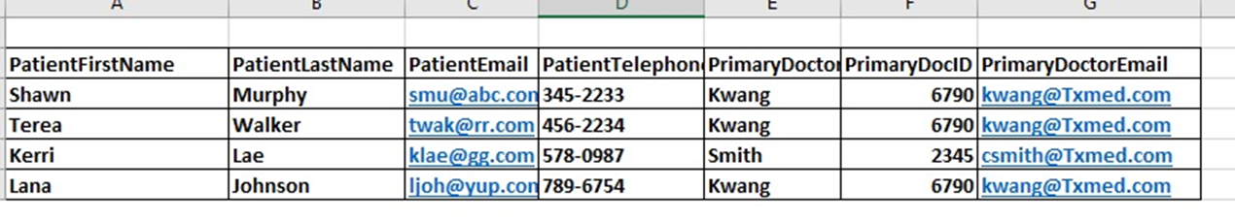

1. The creation of a database and its tables is a function of which component of the database system: **Database Management System**
2. Microsoft SQL Server is an example of a: **commercial database management system**
3. When you type the URL of a website in your browser, your computer is contacting the **Web Server** in order to obtain information to display on your browser
4. DBMS stands for: **Database Management System**
5. Which of the following would be an example of database metadata? Ans: **Names of tables in a database**
6. A relational database stores data in the form of: **Tables**
7. Which of the following is a function of the DBMS (database management system) in a database system? Ans: **Controls concurrency**
8. In the following spreadsheet, identify the themes that help to break this list in to a relational database tables. Ans: **Patient, Doctor, Insurance**

Name of Spreadsheet: Patient

Column Headings: PatientSSN, PatientName, PatientAddress, DoctorID, DoctorName, InsuranceName, Insurance Type, InsuranceDescription

1. When working with data in a list, if changing information in one record, causes some of the other data in the list to become inconsistent, what kind of modification problem does this present? Ans: **Update**
2. **Query** is used to combine data together in different tables in relational databases
3. The major difference that Web 2.0 brought to websites: **Ability users to interact with websites**
4. **Meta data** is data about the structure of a database such as names of tables, fields names of columns
5. **Big Data** is the term used to describe the enormous amount of data generated by Web and mobile applications in today's information environment
6. When working with data in a list, if adding data causes missing data, what kind of modification problem does this present? Ans: **Insert**
7. **Database Application** sits between the end user and the DBMS (Database Management System)
8. **Database** is a self-describing collection of records
9. SQL stands for: **Structured Query Language**
10. When working with data in a list, if the removal of one record results in the removal of an entire theme of information, what kind of modification problem does this present? Ans: **Delete**

**Quiz # 2**

1. In the SQL query SELECT CustomerFirstName, CustomerLastName, Telephone, ZipCode FROM CUSTOMER WHERE Telephone IS NULL;

The first column that appears in the query result would be: **CustomerFirstName**

1. Which of the following is true of the SQL statement below

SELECT Make, Model

FROM CAR

Where Model IN ('Altima', 'Sentra','Maxima');

Ans: **The query will show the make and model columns from the CAR table that have car model of Altima, Sentra OR Maxima**

1. SELECT COUNT (*)

FROM SALES

will display: **The number of rows in the SALES table**

1. SELECT C.CustomerID, OrderID,OrderTotal

FROM CUSTOMER AS C, ORDER AS O

WHERE C.CustomerID=O.CustomerID

is an example of an SQL: **Join**

1. Why would the following SQL statement not work

SELECT CustomerLastName, SUM(SALES)

FROM Customer

WHERE SALES > 20;

Ans: **You cannot combine table column names with built in functions except for Grouping**

1. In the SQL statement

SELECT FirstName, LastName

FROM CUSTOMER

ORDER BY CustomerID;

Which of the following is a true statement: **The results will be sorted by CustomerID in ascending order**

1. SELECT OrderID, OrderItem

FROM ORDER

WHERE OrderID <> 20;

Will display: **OrderId and OrderItem from the ORDER table that have an OrderID not equal to 20**

1. SELECT CustomerLastName, CustomerFirstName, CustomerDOB

FROM CUSTOMER

ORDER BY CustomerLastName DESC, CustomerFirstName

will display the results: **Sorted in descending order by CustomerLastName first and then ascending order by CustomerFirstName**

1. SELECT *

FROM EMPLOYEE

is an example of SQL: **Data Manipulation Language**

1. SELECT *

FROM ORDER

WHERE OrderName LIKE '2017%'

Will show: **All information from the Order table that have OrderName that starts with 2017**

1. SELECT *

FROM CUSTOMER

WHERE CustomerZip= 38910;

Ans: **Will show all customer records in the Customer table with a zip code of 38910**

1. Which of the following is true based on the SQL statement below?

SELECT *

FROM ENROLLMENT

WHERE StudentDepartment= 'SST'

AND EnrollementYear<2015;

Ans: **The results will show all student records from the ENROLLMENT table that belong to the department of SST and who have a data of enrollment before the year 2015**

1. If you want the DBMS to check for and eliminate duplicate rows, what keyword in SQL can we use: **DISTINCT keyword**
2. The following query will not work because

SELECT *

FROM CUSTOMER

WHERE CustomerBonusPoints > MIN(CustomerBonusPoints);

Ans: **You cannot use built in functions in the WHERE clause**

1. SELECT *

FROM EMPLOYEE

WHERE OfficePhone is NULL;

Ans: **Will show all records from the Employee table that have no values for OfficePhone**

1. In the following SQL statement

SELECT Department, SUM(SALES)

FROM Department

Group by Department;

If you want to add a restriction so we see the sum of sales that is greater than 1000, we will need to use a: **HAVING clause**

1. Which of the listed SQL statements is an equivalent of

SELECT *

FROM CUSTOMER

WHERE CustomerID >= 100 AND <=500;

Ans:

**SELECT \***

**FROM CUSTOMER**

**WHERE CustomerID BETWEEN 100 AND 500**

1. SELECT SupplierID, SupplierName, SupplierRegion, SupplierTelephone

FROM SUPLLIER

WHERESupplierRegion NOT IN ('South','West');

will show: **SupplierID, SupplierName, SupplierRegion, SupplierTelephone for Suppliers that have a Supplier Region not in South OR West**

1. SELECT CustomerLastName, SUM(BonusPoints) AS

TotalBonusPoints

FROM TRANSACTION

GROUP BY CustomerLastName;

Ans: **The result will have two columns. The first column showing each customer lastname listed once and the second column that shows the total bonus points for that customer**

1. SELECT *

FROM CUSTOMERS

WHERE CustomerID <= 450;

will show: **All fields from the CUSTOMER table that have CustomerID less than or equal to 450**

1. SELECT *

FROM CUSTOMER;

Ans: **Will show all records from the customer table**

1. SELECT *

FROM ORDER

WHERE OrderName LIKE '2014%';

will display: **All information from the ORDER table that have OrderName that begins with 2014**

1. SQL **Data Definition Language** statements are used for creating tables, relationships and other structures
2. In the following SQL statement

SELECT Department, SUM(SALES)

FROM Department

Group by Department

If you want to add a restriction so we see only certain departments, we can specify that condition in a: **WHERE clause**

1. SELECT Count (MailingAddress)

FROM CUSTOMER;

Will display: **The total count of records that have a value in the Mailing Address field from the customer table**

**Quiz # 4**

1. In the E/R diagram, UNIFORM CODE is a: **Non-ID dependent weak entity**

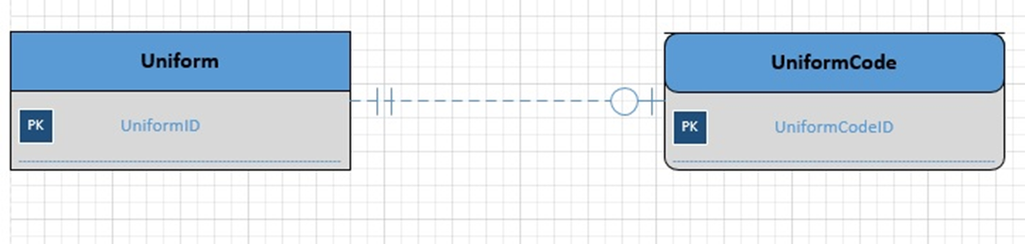

1. Based on the E/R diagram below, how many attributes does Equipment_Repair have: **5**

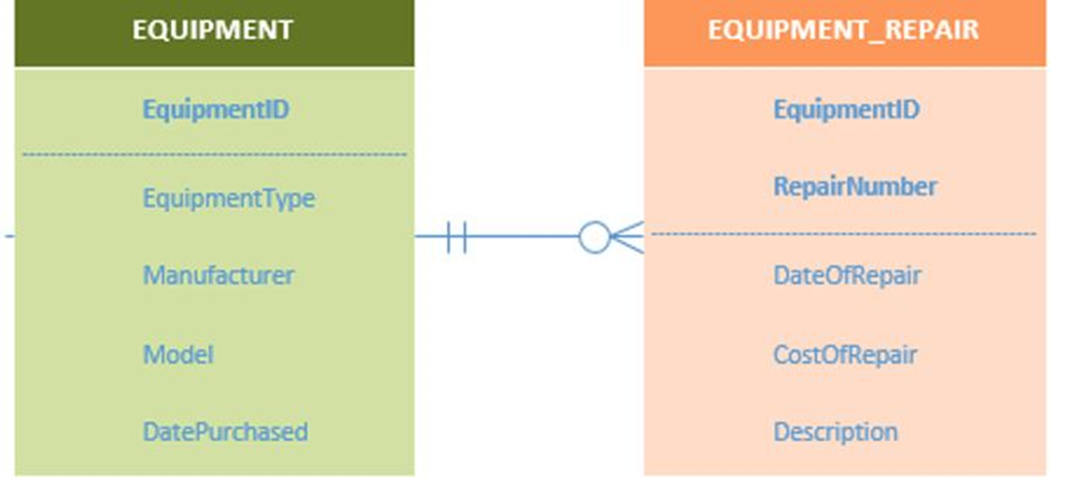

1. Based on the interpretation of the E/R diagram below, we can say that: **A Borrower does not need to borrow a book**

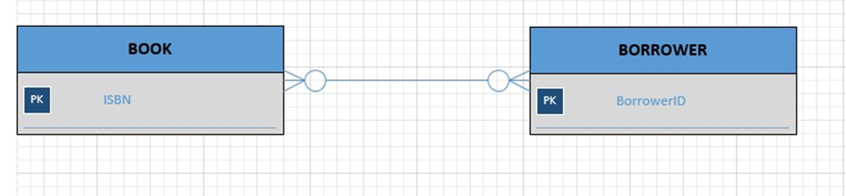

1. In the E/R diagram, the maximum cardinality of BORROWER is: **Many**



1. In the E/R diagram, COMMISSION_RATE is a: **Associative Entity**

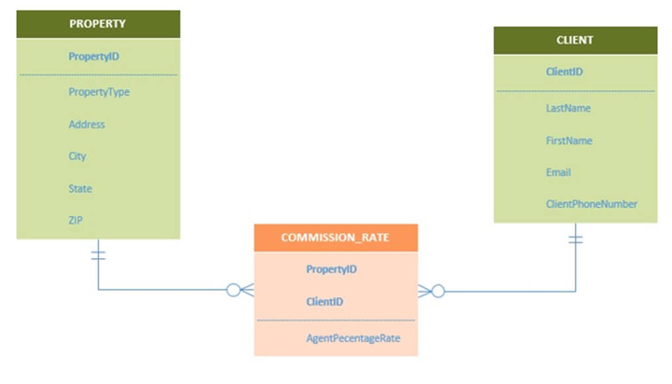

1. **Business Rules** are specific to the organization and shapes the design of the database
2. If the Transaction entity has the following identifiers- AccountNumber and TimeStamp, then the identifier is: **is a composite identifier**
3. In the database development stage if CUSTOMER is identified as something that needs to be tracked. Then CustomerFirstName, CustomerLastName, CustomerPhone would be examples of: **Attributes**
4. In the E/R diagram below, the minimum cardinality of Equipment_Repair is: **Optional**



1. In the E/R diagram, the minimum cardinality of BORROWER is: **Optional**



1. During the **Implementation Stage** phase of the database development, the database is constructed in the DBMS and populated with data
2. Which of the following is true of E/R model below: **Equipment does not need to have a repair**



1. The E/R below diagram represents: **An Inclusive Subtype Entity**

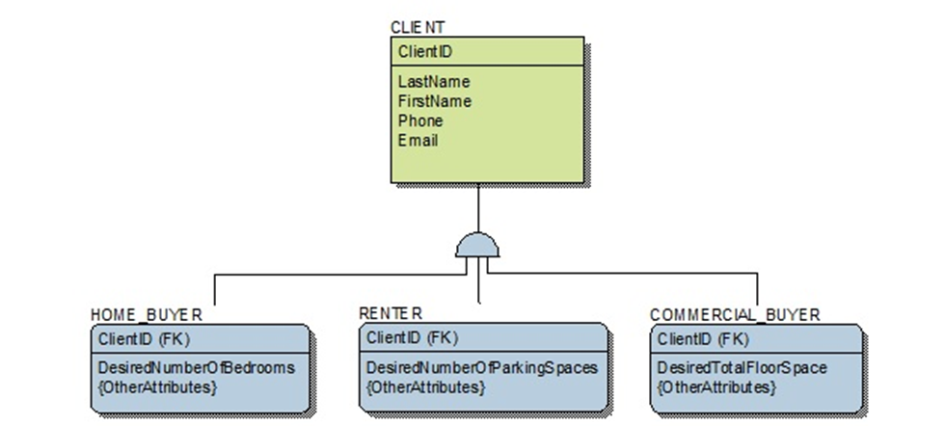

1. A **Entity** is something that users want to keep track of. For example, EMPLOYEE as a collection of all employees is an example of a
2. In the E/R diagram, the minimum cardinality of BOOK is: **optional**



1. Based on the E/R diagram we can say that:  **Commission rate needs to be associated with a property**



1. During the **Requirements Analysis** stage of the database development, system users are interviewed to gather information about the requirements and purpose of the database
2. When an entity has a relationship to itself, it is called a: **Recursive**
3. In the E/R diagram below, the maximum cardinality of Equipment is: **one**



1. **Attributes** describe the entity and have data types and properties

**Quiz # 5**

1. When transforming a data model into database design, we create Tables to represent the entity
2. Which of the following is true when representing a 1:1 binary relationship using the relational model? **The key of either entity is placed in the other as a foreign key.**
3. Each attribute of an entity becomes a(n) **Column** of a table.
4. The first step in the normalization process is to **Identify all candidate keys**
5. In the relation below, identify the determinants

TREATMENT (DoctorID, DoctorName, PatientID, PatientName, InsuranceName, TreatmentDate)

Business Rules: A doctor can treat many patients. A patient can see many doctors. However, a patient sees one particular doctor for one treatment. Many patients can have the same insurance name. **Doctor ID, PatientID**

1. In a relation, if the only determinant that exists is a candidate key, we can say that the relation is normalized to **BCNF** form
2. Which of the following is the correct technique for representing a M:N relationship using the relational model? **An intersection relation is created, and the keys of both parent entities are placed as a composite key in the intersection relation.**
3. What relationship pattern is illustrated by Product_Supplier in the following schema? **Association relationship**

PRODUCT (ProductID, Description) SUPPLIER (SupplierID, ContactName, PhoneNumber) PRODUCT_SUPPLIER (ProductID, SupplierID, Cost)

The product table keeps track of products

The supplier table keeps track of suppliers

Product_Supplier keeps track of which products are supplied by a supplier and its cost.

ProductID in PRODUCT_SUPPLIER must exist in ProductID in PRODUCT

SupplierID in PRODUCT_SUPPLIER must exist in SupplierID in PRODUCT

1. In the relation below, there is only one determinant Customer (CustomerNumber, CustomerFirstName, CustomerLastName, CustomerDateJoined, CustomerPreferences, CustomerZip)

Business Rules: Many customers can join on the same date. Many customers can have the same preferences. **True**

1. In transforming a data model to database design, we create relationships by placing **Foreign Keys** in the respective tables
2. In the relation below

EMPLOYEE (EmployeeNumber, FirstName, LastName, Address, JobTitle)

Which of the following is a determinant? **Employee Number**